Parking information for exhibitors during the Central Kentucky Home + Garden Show

Friday, April 5th and Sunday, April 7th
Hourly parking at High Street Parking lot, “Pay at the Gate”:
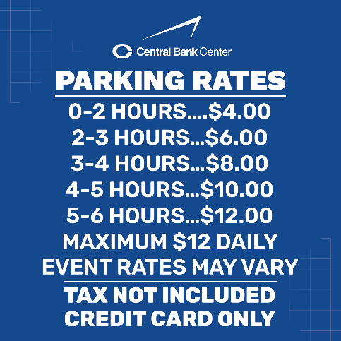

Saturday, April 6th:
Flat rate at High Street Parking lot, “Pay at the Gate”:
$15

THREE-DAY PARKING PASS:
PRE-PAY for a three-day parking pass for the High Street lot. Cost is $41 for a standard vehicle. Trailers are extra. This cost covers all three days and allows for OVERNIGHT PARKING as well as IN AND OUT PRIVILEGES. Use this link to buy your three-day passes. https://am.ticketmaster.com/rupparena/quickbuy?id=Njk=

