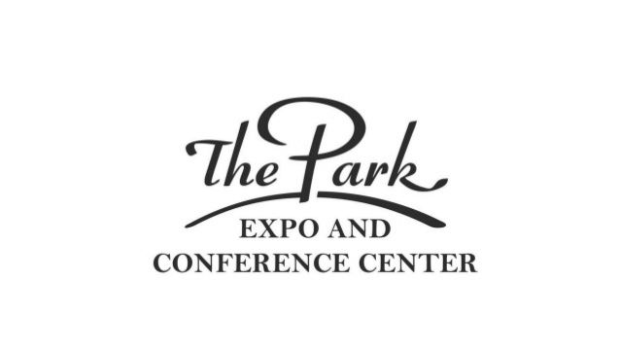 2023 Food Sales Request Form

Information required for any exhibitor requesting permission to sell food products that could be consumed on site.

- Park Expo / Park Property Management, has full control and final say on any food items that are sold at the Expo Center.
- This Exhibitor form is required and should be approved by The Park before any exhibitor space contracts are executed..
- After review of your information, you will be put into the proper category and commission fees and/or flat-rate fees will be assessed and agreed upon prior to being allowed into the event.
- NO SALES of any hot or cold beverage, bottle or can drinks are allowed.
- Once approved you are not allowed to alter any of the food product specifications listed with-in this application.
- All food exhibitors/vendors are required to have a Certificate of Insurance with Park Property Management / The Park Expo & Conference Center as an additional insured. NC Sales and Use tax Certificate as well as Mecklenburg County Tax must be paid by the vendor. You are also required to have all proper NC Health Department or NC Dept. of Agriculture certifications as required for your food products.
- There are several factors that will be taken into consideration during the review process. Food product, packaging, size of serving and pricing. Part of the review process will evaluate if your products are competing with other authorized food vendors that have similar items? Is the food product for on-site consumption or for take home as a gift?
- Decisions by the Park Expo review process are final.

This application must be submitted at least 21 days prior to event move-in day. If you are a last minute exhibitor please call direct to discuss. 980-365-7568

Please Print … you may attach additional relevant information with product photos or other promotional materials etc.

Food Product Description:

Serving Size and / or number in package:

Type of Packaging:

Price of Item:

Food Product Description:

Serving Size and / or number in package:

Type of Packaging:

Price of Item:

Food Product Description:

Serving Size and / or number in package:

Type of Packaging:

Price of Item:

Food Product Description:

Serving Size and / or number in package:

Type of Packaging:

Price of Item:

ATTACH ADDITIONAL SHEET IF REQUIRED

Name of Event ___________________________________________ Event Date ______________________

Company Name ________________________________________ LLC ___ Corp ____ Incorporated ____

Contact Name ___________________________________ Phone Number ___________________________

Email ____________________________________________________________________ OFFICE USE ONLY

Address __________________________________________________________________

City, State and Zip __________________________________________________________

Federal Tax ID number _______ ________________________________

Send completed form to: Attn. hmills@theparkexponc.com

Will respond within 3 business days.

Henry Mills 800 Briar Creek Road, AA 506 Charlotte, NC
For questions call, Henry Mills, Business Manager 980-365-7568

Application Approved: YES Date: _____________ DENIED

